Installation Build Procedures
Interim and Iteration Builds
For combined Dev and Production Build
Revised 7/23/07

Green items are not relevant for interim builds that aren’t posted to the website or wiki.

- Update the Development Notes Builds Wiki page: http://www.jdftech.com/flexwiki/default.aspx/MyWiki/TawalaDevelopmentNotes
for this week, and ask team members to review.

- Freeze VSS

- Do complete “get” of Tawala source code into an empty folder. (Some day I expect to have a dedicated “build” machine.)

- Build TawalaTest solution and run nUnit test suite to make sure all tests run green

- Open Tawala solution

- Set solution configuration to Release

- Build entire solution, including Setup project

- Zip setup files (Setup.exe and Tawala.msi) into Tawala.zip.

- Run WinZip Self-Extractor wizard to produce executable installer.
  - Input = Tawala.zip
  - Take all default options except: Be sure to check the “Unzip automatically” option at the end of the wizard. After you click next you’ll see a warning about “some sysops refuse to accept files.” Click “Yes” to Continue anyway.

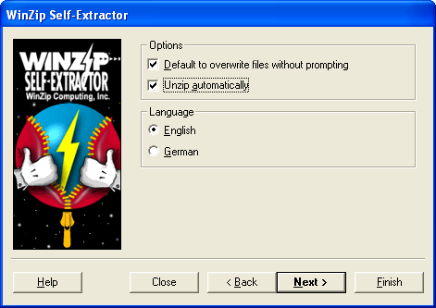

- Test the resultant installer

- Test the installed app itself. Exercise it thoroughly, because stuff that was working before can be broken now!

- Label the entire VSS project (at the root $ level):
  - Label = “Build num” (e.g., Build 4)
  - Details = “Build num – date” (e.g., Build 4 - 4/8/05)

- Check out Setup.vdproj and config.xml under the Setup project

- Select the Setup project in the Tawala solution to update it for the next build:
  - In the Properties, increment the Version property (least significant digit); answer “Yes” when prompted about changing ProductCode
  - In the Properties, update the Description property to reflect the next Build number

- In config.xml update the build attribute to reflect the next Build number

- Check in Setup.vdproj and config.xml

- Unfreeze VSS.

- Upload the installation file (Tawala.exe) to the Tawala dev server as follows:
  - Using the Cygwin Bash shell, navigate to the folder where the installation file resides on your system.
  - Enter the following command, which uploads the file from your system to my home directory on the server:
scp Tawala.exe jdf@botswana.tawala.com:
Note: the colon (:) at the end
Note: my password is jdf%0926
  - After the upload is complete, use the putty shell to log into my home directory on the botswana server
  - Execute the following command, which copies the installation file from my home directory to the proper location for the Downloads page.
sudo sh /home/tawala/bin/upgrade-designer

- Update the client info XML file on the server:
  - After the copy, the clientinfo.xml file will open automatically in the VIM editor *
  - arrow key to build number
  - ‘r’ (replace) and type in new number [also can use ‘i’ for insert mode]
  - :wq to write and quit

  - Log into the dev server Downloads page and make sure the proper installation file is downloaded.

- Send out distribution message to: staff@tawala.com

The following actions are not necessary; John usually does them, but they’re just precautionary:

- Copy the version numbers for Designer.exe and all the DLLs into the Build Notes page

- Copy the installation file to the jdftech dev server for downloads via the Wiki:
  - C:\Inetpup\wwwroot\Docs\ Builds\....
(Note: the above folder is available via FTP as “Builds” at the root level)

- Update the Iteration Builds page to point at the proper location for the server download.

If necessary, remind Tony or Sergei to promote the Build code to the Dev server.

